**1 - What is ServiceNow**

**ServiceNow** is a software company based in Santa Clara, California, founded by Fred Luddy in 2003, to solve problems large enterprises face with traditional IT delivery by providing a robust, simple-to-use, cloud-based environment in which business people can solve their business problems themselves.

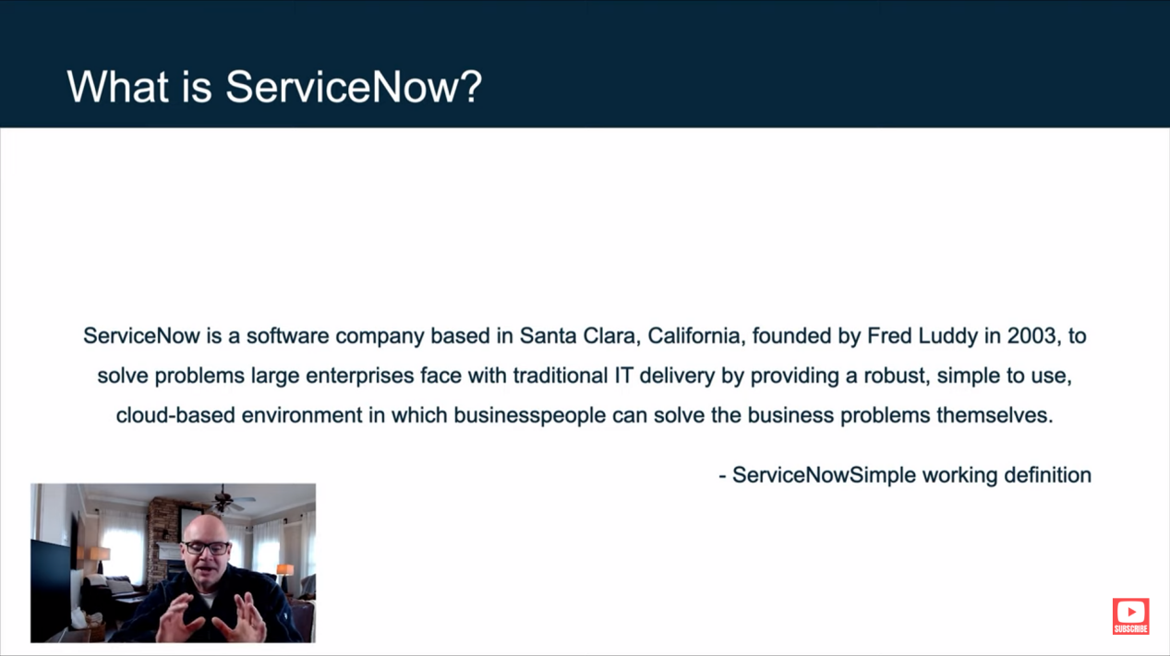

**Purpose** - ServiceNow offers a platform that seamlessly connects IT services with business challenges, enabling users to address business issues independently. It streamlines the creation of no-code automated workflows, enhancing productivity and efficiency across various enterprise functions. Additionally, it delivers real-time insights that empower teams to address and resolve problems swiftly.

**Platform** - ServiceNow’s platform, known as ‘Now,’ includes all of ServiceNow’s products. It offers a unified technology stack for various enterprise departments, workflows, and processes. This cloud-based solution operates as an Application Platform as a Service (APaaS).

**Infrastructure** - ServiceNow’s infrastructure consists of :

Compute Resources - Includes data centers, racks, servers, ports, network equipment, and cooling fans, etc.

Security - The platform uses various security technologies that are certified by third-party security agencies.

Service Level Agreements - Redundant data centers ensure backup and failover. Every layer, including devices, power, and network resources, has built-in redundancy.

Backups - Four full backups are taken daily each week, and there are daily differential backups for six days.

ANANYA CHOUDHARY